Azure Monitor

Monitoring:
• A working app is not enough.
• We must know its status, how it performs, and when it has problems.
• This is done via monitoring.

Azure Monitor:
Azure Monitor is a comprehensive monitoring solution for collecting, analyzing, and responding to monitoring data from your cloud and on-premises environments. we can use Azure Monitor to maximize the availability and performance of our applications and services. It helps you understand how your applications are performing and allows you to manually and programmatically respond to system events.
Azure Monitor collects and aggregates the data from every layer and component of your system across multiple Azure and non-Azure subscriptions and tenants. It stores it in a common data platform for consumption by a common set of tools that can analyze, visualize, and/or respond to the data. You can also integrate other Microsoft and non-Microsoft tools.
• Azure offers a lot of built in monitoring mechanisms
• It’s a good idea to be familiar with as many as possible
• Also – a centralized monitoring hub where all monitoring data is streamed, and can be queried, or used for triggers.
• Extremely cost effective

Monitoring is based on two types of data:

- Numeric values describing resource’s aspect at
Metrics
a specific point in time
- Examples: CPU, Disk, RAM, Response Time

- Events that occurred in the system
Logs
- Textual & numeric
- Examples: System started, Error occurred

Azure Monitor can monitor these types of resources in Azure, other clouds, or on-premises:
- Applications
- Virtual machines
- Guest operating systems
- Containers including Prometheus metrics
- Databases
- Security events in combination with Azure Sentinel
- Networking events and health in combination with Network Watcher
- Custom sources that use the APIs to get data into Azure Monitor
We can also export monitoring data from Azure Monitor into other systems so you can:
- Integrate with other third-party and open-source monitoring and visualization tools
- Integrate with ticketing and other ITSM systems

Logs:
- Almost every Azure resource generate logs.
- Might contain data about performance, events, errors etc.

Alerts
• Get notifications about events in your resources
• Examples:
VM’s CPU goes above 90%
More than 20% of requests fails
Server error occurs in the last hour

Log Analytics Workspace:

• A central location for storing, organizing and analyzing logs
• Need central repository to be stored and viewed the logs and this is done by Log Analytics Workspace.
• Aggregates logs from all connected, monitored resources
• Uses specialized query language to query logs
• Located in a designated region
• Better be the same region of the resources to save costs

Insights:

In Azure Monitor, "Insights" refers to pre-built monitoring solutions that provide focused views of specific Azure resources or services, offering deeper insights into their performance, health, and usage. These insights simplify monitoring by consolidating relevant data and providing actionable visualizations and recommendations
The following table describes some of the larger insights:
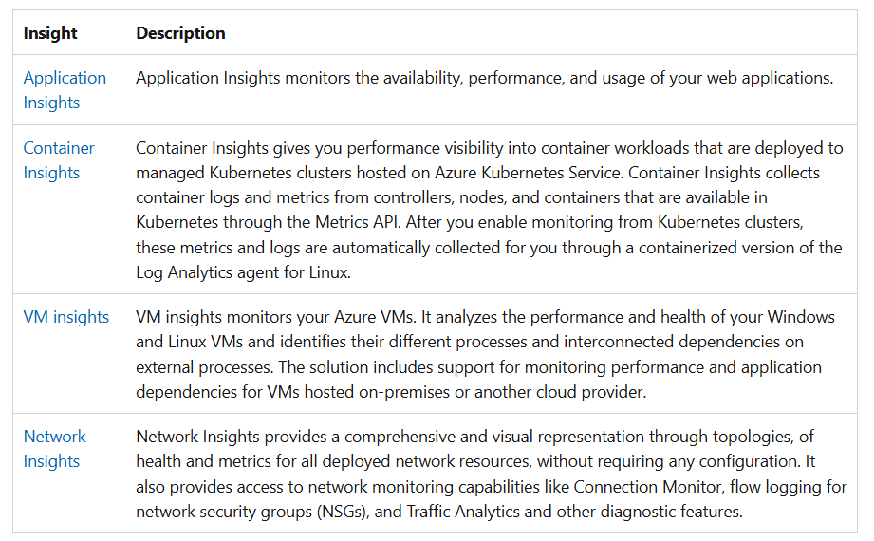

Diagnostic settings in Azure Monitor:
Diagnostic settings in Azure Monitor collect detailed logs and metrics from Azure resources, allowing you to route this data to different destinations for analysis, troubleshooting, and archiving.
You configure these settings for a specific Azure resource, choosing which categories of logs (e.g., administrative, security, service health) and metrics to collect, and then specifying one or more destinations for that data. Common destinations include a Log Analytics workspace for deep querying and dashboards using Kusto Query Language (KQL), an Event Hub for real-time streaming to third-party tools like SIEMs, and a Storage Account for long-term archiving and compliance.
Sources:
Diagnostic settings can collect data from the sources in the following table:
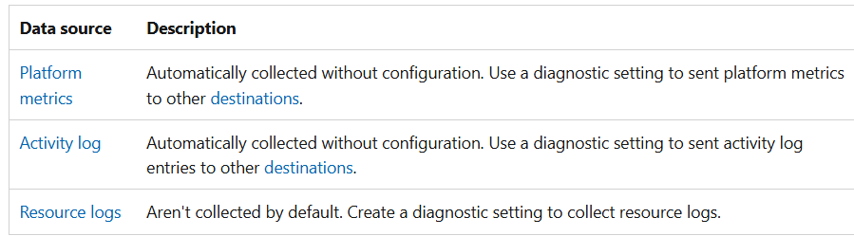
What is mean by Platform metrics?
In Azure Monitor, platform metrics are automatically collected numerical values that reflect the health, performance, and usage of your Azure resources at regular intervals, such as CPU utilization, network traffic, or request counts. These metrics are generated directly by Azure resources without requiring any user configuration and are stored in Azure Monitor's time-series database, making them ideal for real-time alerting, trend analysis, and troubleshooting using the Metrics Explorer tool.
what is mean by platform in azure monitor?
In Azure Monitor, "platform" refers to the Azure platform itself and its services, from which platform metrics (standard, automatically collected data) and other diagnostic data are generated.
Destinations:
Diagnostic settings send data to the following destinations services. To ensure the security of data in transit, all destination endpoints are configured to support TLS 1.2.
A single diagnostic setting can define no more than one of each of the destinations. If you want to send data to more than one of a particular destination type (for example, two different Log Analytics workspaces), create multiple settings. Each resource can have up to five diagnostic settings.
- Log Analytics workspace
- Azure Storage account
- Azure Event Hubs
- Azure Monitor partner solutions
Visualize:
Visualizations such as charts and tables are effective tools for summarizing monitoring data and presenting it to different audiences. Azure Monitor has its own features for visualizing monitoring data and uses other Azure services for publishing it to different audiences. Power BI and Grafana aren't officially part of the Azure Monitor product, but they're a core integration and part of the Azure Monitor.

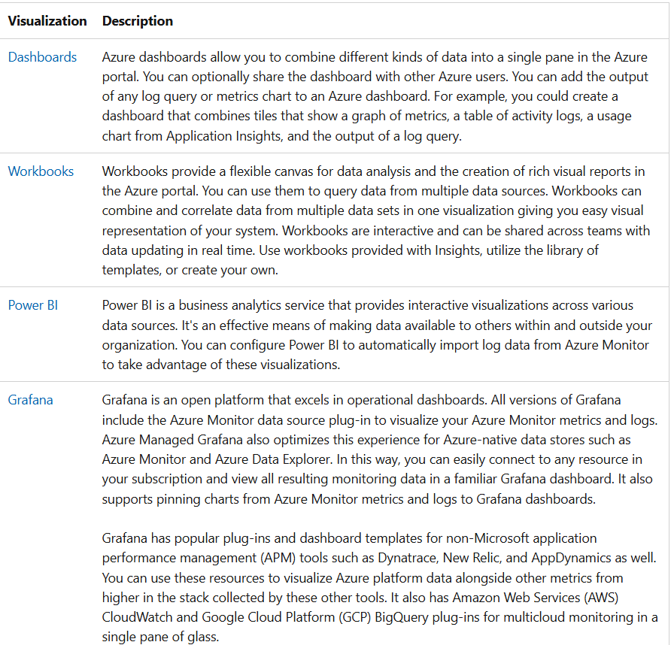

Analyze:
The Azure portal contains built-in tools that allow you to analyze monitoring data:
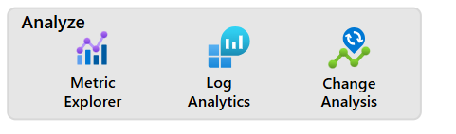

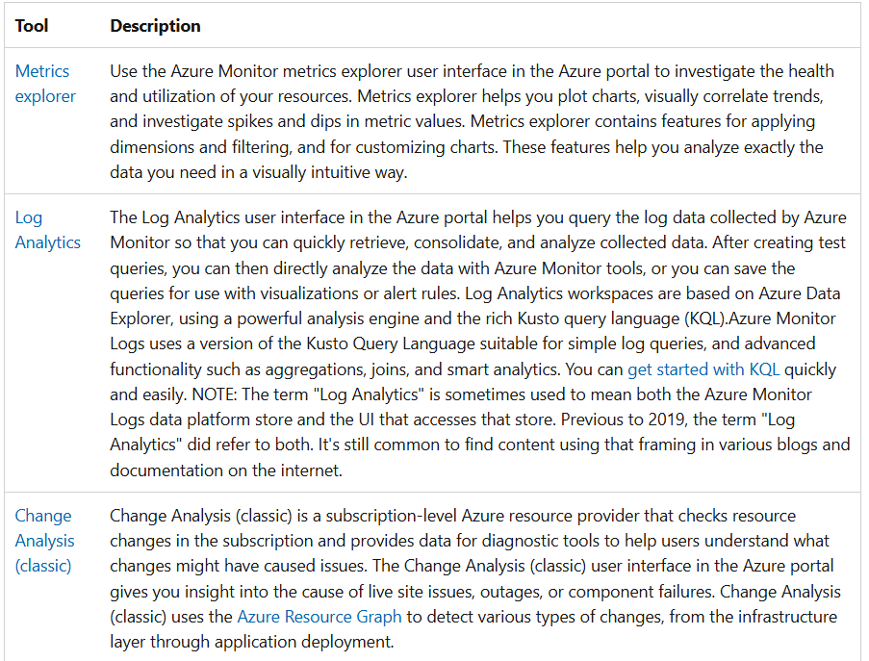

Respond:
An effective monitoring solution proactively responds to critical events, without the need for an individual or team to notice the issue. The response could be a text or email to an administrator, or an automated process that attempts to correct an error condition.
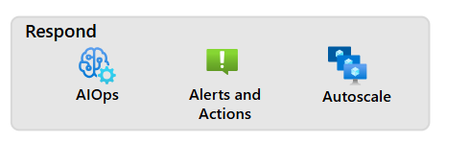
Artificial Intelligence for IT Operations (AIOps): can improve service quality and reliability by using machine learning to process and automatically act on data you collect from applications, services, and IT resources into Azure Monitor. It automates data-driven tasks, predicts capacity usage, identifies performance issues, and detects anomalies across applications, services, and IT resources. These features simplify IT monitoring and operations without requiring machine learning expertise.
Azure Monitor Alerts(Alerts and Action): notify you of critical conditions and can take corrective action. Alert rules can be based on metric or log data.
- Metric alert rules provide near-real-time alerts based on collected metrics.
- Log search alert rules based on logs allow for complex logic across data from multiple sources.
Alert rules use action groups, which can perform actions such as sending email or SMS notifications. Action groups can send notifications using webhooks to trigger external processes or to integrate with your IT service management tools. Action groups, actions, and sets of recipients can be shared across multiple rules.
Autoscale: allows you to dynamically control the number of resources running to handle the load on your application. You can create rules that use Azure Monitor metrics to determine when to automatically add resources when the load increases or remove resources that are sitting idle. You can specify a minimum and maximum number of instances, and the logic for when to increase or decrease resources to save money and to increase performance.
Integrate:
You may need to integrate Azure Monitor with other systems or to build custom solutions that use your monitoring data. These Azure services work with Azure Monitor to provide integration capabilities.
The following diagram and table show only a few of the possible integrations:
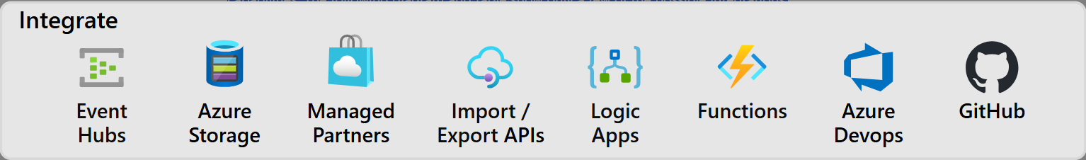

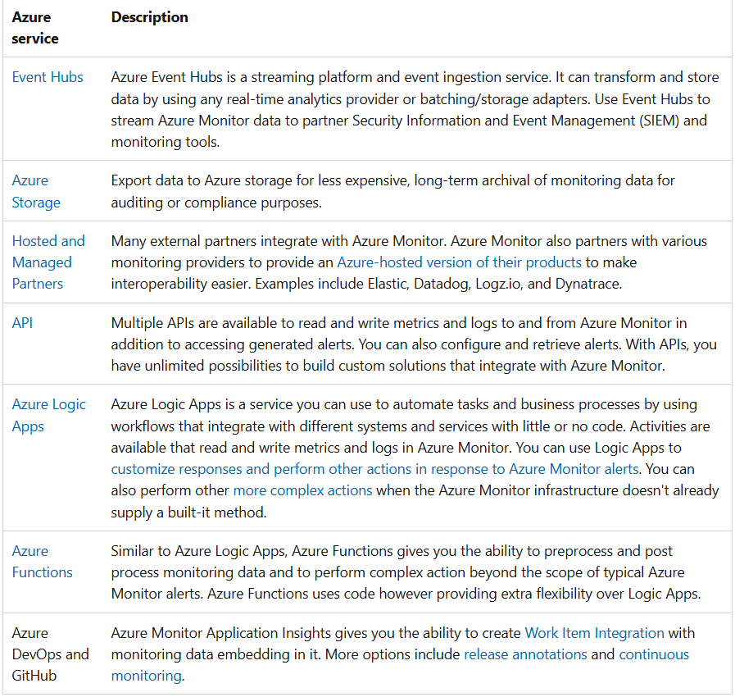

The following diagram shows a high-level architecture view of Azure Monitor:
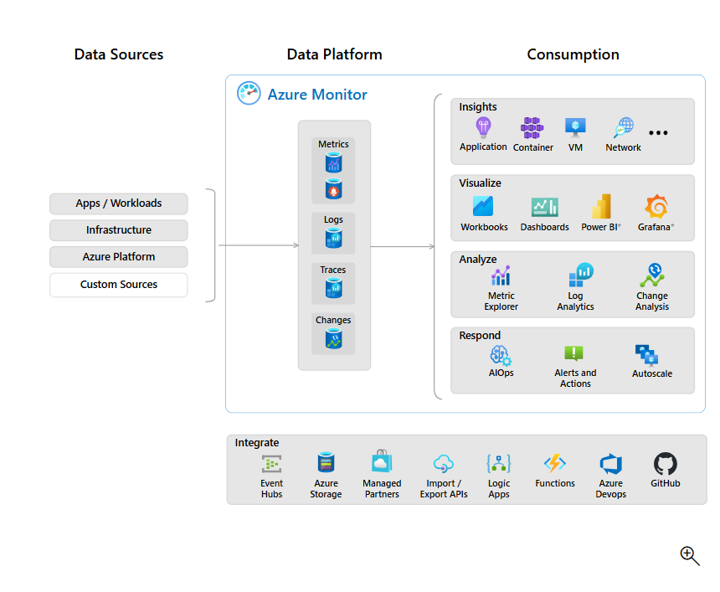
The diagram depicts the Azure Monitor system components:
- Data sources are the types of resources being monitored.
- The data is collected and routed to the data platform. Clicking on the diagram shows these options, which are also called out in detail later in this article.
- The data platform stores the collected monitoring data. Azure Monitor's core data platform has stores for metrics, logs, traces, and changes. System Center Operations Manager MI uses its own database hosted in SQL Managed Instance.
- The consumption section shows the components that use data from the data platform.
  - Azure Monitor's core consumption methods include tools to provide insights, visualize, and analyze data. The visualization tools build on the analysis tools and the insights build on top of both the visualization and analysis tools.
  - There are additional mechanisms to help you respond to incoming monitoring data.
- Interoperability options are shown in the integrate section. Not all services integrate at all levels.

Frequently asked questions:
What's the difference between Azure Monitor, Log Analytics, and Application Insights?
In September 2018, Microsoft combined Azure Monitor, Log Analytics, and Application Insights into a single service to provide powerful end-to-end monitoring of your applications and the components they rely on. Features in Log Analytics and Application Insights haven't changed, although some features are rebranded to Azure Monitor to better reflect their new scope. The log data engine and query language of Log Analytics is now referred to as Azure Monitor Logs.
How much does Azure Monitor cost?
The cost of Azure Monitor is based on your usage of different features and is primarily determined by the amount of data you collect. For more information, see the following articles:
- Azure Monitor cost and usage
- View Azure Monitor usage and charges
- Cost optimization in Azure Monitor
Is there an on-premises version of Azure Monitor?
No. Azure Monitor is a scalable cloud service that processes and stores large amounts of data, although Azure Monitor can monitor resources that are on-premises and in other clouds.

